1
  - Business background:
There are many big shops which selling different kind of products. Those shops can provide both type of selling services: in shops(offline) and by delivery. As an example we can take brands like Walmart, Amazon, Target and Korzinka. These brands spend huge amount of money to take insights from data and improve their capitals. Ability to use data for future steps in such business is upmost important.

  - Problems Because of poor Data Management
If such brands does not have good data management because of inaccurate data they will make a lot of wrong steps that will lead to big mistakes which negatively affect to the business.

  - Benefits from implementing a Data Warehouse
By using data warehouse and taking good insights from it helps to various areas which improve busniness. We can analyze and decide:

1Which products should be discontinued or promoted due to approaching expiration dates.
2. In which region or in what season we should order some products from supplier more than as usual.
3.In which city we can open more branches or where to close.
And so far.

  - Datasets Description
The first dataset contains the following information about sales in 52 cities from 5 counties from markets(offline).

Orders:
OrderId: unique identifier for each order
OrderDate: Date when order is made
OrderStatus: Whether order is completed, cancelled or returned
OrerType: Allways offline since order is made from shop

Customers:
CustomerId: unique identifier for each customer
CustomerName: First and last name of customer
Gender: Is customer Man or Woman Male/Female
CustomerEmail: Email of customer

Products:
ProductId: Unique identifier for each product
ProductName: Name of Product
Category: Category of product
Brand: Brand of product
MadeIn: Where the product was made

Payments:
PaymentId: Unique identifier for each for each product
PymentType: The type of payment Cash/Credit Card/Online payment
Quantity: Number of products that were bought.
Currency: Currency depending on branch location
UnitPriceInUSD: price of one product in USD
TotalAmountInUSD: total price of all products in USD
USDRate: USD rate depending Currency
UnitPriceInLocalCurrency: price of one product in local currency
TotalPriceInLocalCurrency: total price of all products in local currency

City:
CityID : : Unique identifier for each for each city
Country: Country where city is located
Region: Region of country
Continent: Continent of country
PostalCode: PostalCode for each city

Branches:
BranchId: Unique identifier for each branch
BranchName: Name of the branch store
BranchAddress: Physical street address of the branch
BranchOpenedYear: Year when the branch was opened
BranchSizeSqm: Size of the branch in square meters
BranchManagerId: Unique identifier for the branch manager
BranchManagerName: Full name of the branch manager
BranchManagerEmail: Email address of the branch manager
BranchManagerGender: Whether branch manager is Male or Female
BranchManagerBirthDate: Date of birth of the branch manager

Suppliers:
SupplierId: Unique identifier for each supplier
Supplier: Name of the supplier company
SupplierEmail: Email address of the supplier
SupplierStreetAddress: Street address of the supplier
SupplierCity: City where the supplier is located
SupplierCountry: Country where the supplier is located
SupplierPrimaryIndustry: Main industry or product category the supplier provides (e.g. Electronics, Clothing)

Sellers (Employees):
SellerId: Unique identifier for each seller
SellerName: Full name of the seller
SellerEmail: Email address of the seller
SellerGender: Whether seller is Male or Female
SellerBirthDate: Date of birth of the seller

Datasets Description
The second dataset contains the following information about sales in 52 cities from 5 countries from online orders delivered by couriers.

Orders:
OrderId: Unique identifier for each order
OrderDate: Date when order is made
OrderStatus: Whether order is delivered, pending or returned
OrderType: Always online since order is placed through digital platform and delivered by courier

Customers:
CustomerId: Unique identifier for each customer
CustomerName: First and last name of customer
CustomerEmail: Email address of customer
CustomerBirthDate: Date of birth of customer
CustomerAddress: Delivery address of customer where order will be delivered
CustomerGender: Whether customer is Male or Female

Products:
ProductId: Unique identifier for each product
ProductName: Name of product
ProductCategory: Category of product
ProductBrand: Brand of product
ProductMadeIn: Country where the product was made

Payments:
PaymentId: Unique identifier for each payment
Quantity: Number of products purchased in the order
UnitPriceInUSD: Price of one unit of product in USD
TotalAmountInUSD: Total price of all purchased products in USD
PaymentType: Type of payment — Cash on Delivery, Card or Online Payment
Currency: Local currency depending on customer delivery location
USDRate: Exchange rate from USD to local currency
UnitPriceInLocalCurrency: Price of one unit of product in local currency
TotalPriceInLocalCurrency: Total price of all purchased products in local currency

City:
CityID: Unique identifier for each city
City: Name of the city where delivery is made
Country: Country where the city is located
Region: Region or state within the country
Continent: Continent where the country is located
PostalCode: Postal code of the city

Suppliers:
SupplierId: Unique identifier for each supplier
Supplier: Name of the supplier company
SupplierEmail: Email address of the supplier
SupplierStreetAddress: Street address of the supplier
SupplierCity: City where the supplier is located
SupplierCountry: Country where the supplier is located
SupplierPrimaryIndustry: Main industry or product category the supplier provides

Couriers:
CourierId: Unique identifier for each courier
CourierName: Full name of the courier who delivers the order
CourierEmail: Email address of the courier
CourierGender: Whether courier is Male or Female
CourierBirthDate: Date of birth of the courier

Branches:
BranchId: Unique identifier for each branch from which the order is dispatched
BranchName: Name of the branch store
BranchAddress: Physical street address of the branch
BranchOpenedYear: Year when the branch was opened
BranchSizeSqm: Size of the branch in square meters
BranchManagerId: Unique identifier for the branch manager
BranchManagerName: Full name of the branch manager
BranchManagerEmail: Email address of the branch manager
BranchManagerGender: Whether branch manager is Male or Female
BranchManagerBirthDate: Date of birth of the branch manager

2GRAIN / DIM / FACT

- Determine the grain of the data, which refers to the level of detail or specificity at which the data is captured. Additionally, provide a description explaining why you have selected this particular grain (4 steps).

Step 1 — Define the grain
The grain is one row in the fact table representing one order line, where a customer bought one product from one supplier through one branch.
Step 2 Identify why this level of detail was chosen
We chose this level of detail because one order can include several products from different suppliers, so we need a separate row for each product to track them individually.
Step 3 Confirm uniqueness of the grain
A row is uniquely identified by the OrderID and ProductID together, since one order can have multiple products, but each product in that order gets its own row.

Step 4 Link the grain to dimensions
This grain connects to all our dimension tables (customer, product, supplier, branch, employee, payment, and date) and lets us measure things like quantity and total amount at this detailed, per-product level.

- For each dimension and fact table, populate the tables with the relevant attributes and data types. Make sure to include all necessary information and specify the appropriate data types for each attribute.

Dim Description
<description>

DIM_CUSTOMER
Table Description
Column name | Description | Data Type
CustomerKey | Surrogate key | INT
CustomerID | Source customer ID | VARCHAR
CustomerName | Full name | VARCHAR
DateOfBirth | Birth date | DATE
Gender | Gender | VARCHAR
CustomerEmail | Email address | VARCHAR

Sample Data
CustomerKey | CustomerID | CustomerName | DateOfBirth | Gender | CustomerEmail
1 | CUST001504 | Aarav Verma | 6/17/2001 | Male | aarav.verma@gmail.com
DIM_PRODUCT
Table Description
Column name | Description | Data Type
ProductKey | Surrogate key | INT
ProductID | Source product ID | VARCHAR
ProductName | Name of product | VARCHAR
Category | Product category | VARCHAR
Brand | Product brand | VARCHAR
MadeIn | Country of manufacture | VARCHAR
Sample Data
ProductKey | ProductID | ProductName | Category | Brand | MadeIn
1 | P00014 | Drone Mini | Electronics | DJI | China

DIM_BRANCH
Table Description
Column name | Description | Data Type
BranchKey | Surrogate key | INT
BranchID | Source branch ID | VARCHAR
BranchName | Name of the branch | VARCHAR
BranchAddress | Street address | VARCHAR
BranchOpenedYear | Year branch opened | INT
BranchSizeSqm | Floor size in sqm | DECIMAL
ManagerKey | Surrogate key | INT
BranchManagerID | Source manager ID | VARCHAR
BranchManagerName | Full name | VARCHAR
BranchManagerEmail | Email address | VARCHAR
BranchManagerGender | Gender | VARCHAR
BranchManagerBirthDate | Date of birth | DATE

Sample Data
BranchKey | BranchID | BranchName | BranchAddress | BranchOpenedYear | BranchSizeSqm | ManagerKey | BranchManagerID | BranchManagerName | BranchManagerEmail | BranchManagerGender | BranchManagerBirthDate
1 | BR039 | UzbekLand Pune | Hinjewadi | 2018 | 1300 | 1 | BM039 | Christopher Reed | chris.reed@uzbekland.com | Male | 1/30/1982
DIM_LOCATION
Table Description
Column name | Description | Data Type
CityKey | Surrogate key | INT
CityID | Source city ID | VARCHAR
City | City name | VARCHAR
Country | Country name | VARCHAR
Region | Regional grouping | VARCHAR
Continent | Continent name | VARCHAR
PostalCode | Postal code | VARCHAR
Sample Data
CityKey | CityID | City | Country | Region | Continent | PostalCode
1 | CTY039 | Pune | India | South Asia | Asia | 411001
DIM_FULFILLMENT_PERSON
Table Description
Column name | Description | Data Type
EmployeeKey | Surrogate key | INT
EmployeeID | Source seller ID | VARCHAR
EmployeeName | Full name | VARCHAR
EmployeeEmail | Email address | VARCHAR
EmployeeGender | Gender | VARCHAR
EmployeeBirthDate | Date of birth | DATE
EmployeeRole | Courier/Seller | VARCHAR
Sample Data
EmployeeKey | EmployeeID | EmployeeName | EmployeeEmail | EmployeeGender | EmployeeBirthDate | EmployeeRole
1 | EMP0039 | Kevin Ward | kevin.ward@uzbekland.com | Male | 10/22/1995 | Seller

DIM_SUPPLIER
Table Description
Column name | Description | Data Type
SupplierKey | Surrogate key | INT
SupplierID | Source supplier ID | VARCHAR
SupplierName | Supplier company name | VARCHAR
SupplierEmail | Contact email | VARCHAR
SupplierStreetAddress | Street address | VARCHAR
SupplierCity | City of supplier | VARCHAR
SupplierCountry | Country of supplier | VARCHAR
SupplierPrimaryIndustry | Main industry | VARCHAR
Sample Data
SupplierKey | SupplierID | SupplierName | SupplierEmail | SupplierStreetAddress | SupplierCity | SupplierCountry | SupplierPrimaryIndustry
1 | SUP004 | Ingram Micro | ingram.micro@gmail.com | 3351 Michelson Dr, Suite 100 | Irvine | United States | IT Supply Chain

DIM_PAYMENT
Table Description
Column name | Description | Data Type
PaymentKey | Surrogate key | INT
PaymentID | Source payment ID | VARCHAR
PaymentType | Payment method | VARCHAR
Currency | Currency code | VARCHAR
USDRate | Exchange rate to USD | DECIMAL
Sample Data
PaymentKey | PaymentID | PaymentType | Currency | USDRate
1 | PAY500001 | Cash | INR | 0.012

DIM_DATE
Column name | Description | Data Type
DateKey | Surrogate key | INT
Date | Date | DATE
Year | Year | INT
Month | Month | INT
DayOfWeek | Day of week | INT
Quarter | Quarter 1/2/3/4 | INT

FACT_SALES
Column name | Description | Data Type
SalesKey | Surrogate primary key | INT
OrderID | Source order ID | VARCHAR
DateKey | FK → DIM_DATE | INT
CustomerKey | FK → DIM_CUSTOMER | INT
ProductKey | FK → DIM_PRODUCT | INT
BranchKey | FK → DIM_BRANCH | INT
EmployeeKey | FK → DIM_ FULFILLMENT_PERSON | INT
SupplierKey | FK → DIM_SUPPLIER | INT
PaymentKey | FK → DIM_PAYMENT | INT
OrderStatus | Status of the order | VARCHAR
OrderType | Type of order | VARCHAR
Quantity | Units purchased | INT
UnitPriceInUSD | Price per unit in USD | DECIMAL
TotalAmountUSD | Total in USD | DECIMAL
UnitPriceInLocalCurrency | Price per unit in local currency | DECIMAL
TotalPriceInLocalCurrency | Total in local currency | DECIMAL

Sample Data
SalesKey | OrderID | DateKey | CustomerKey | ProductKey | BranchKey | EmployeeKey | SupplierKey | PaymentKey | OrderStatus | OrderType | Quantity | UnitPriceInUSD | TotalAmountUSD | UnitPriceInLocalCurrency | TotalPriceInLocalCurrency
1 | ORD500001 | 1/31/2026 | 1 | 1 | 1 | 1 | 1 | 1 | Completed | offline | 3 | 106.59 | 319.86 | 8882.5 | 26655

3. BUSINESS LAYER DIMENSIONAL MODEL

Design Overview
The dimensional model was created from the 3NF business layer to make reporting and data analysis faster and easier. Unlike the 3NF model, which is designed to reduce data duplication, the dimensional model is designed to simplify analytical queries.
The model uses a star schema. In this design, one central fact table stores the sales transactions, while several dimension tables store descriptive information about customers, products, employees, branches, suppliers, payments, geography, and dates.
The central table is FACT_SALES. Each sales transaction is linked to the related dimensions through surrogate keys. This allows users to analyze sales from different perspectives, such as by customer, product, branch, employee, supplier, payment method, location, or time.
The Customer dimension is implemented as a Slowly Changing Dimension Type 2 (SCD Type 2) because customer information, such as email or address, may change over time. Instead of replacing the old information, a new record is created while the previous record is kept. This preserves the history of customer data and allows historical reporting.
The Date dimension is a special case. It is not loaded from the 3NF layer because calendar information does not come from a source system. Instead, it is generated once using a SQL script and reused throughout the data warehouse.
Each dimension table contains a surrogate key, the original source identifier, source triplet columns (SOURCE_DB, SOURCE_TABLE, SOURCE_SYSTEM), and audit columns (INSERT_DT and UPDATE_DT). The Customer dimension also includes the SCD Type 2 fields START_DT, END_DT, and IS_ACTIVE.
Fact Table
The central table in the star schema is FACT_SALES. It stores the measurable values of each sales transaction together with references to all related dimensions.
The fact table contains foreign keys to the following dimensions:
- DIM_DATE
- DIM_CUSTOMER
- DIM_PRODUCT
- DIM_EMPLOYEE
- DIM_BRANCH
- DIM_SUPPLIER
- DIM_PAYMENT
The fact table stores the following measures:
- QUANTITY
- UNIT_PRICE_USD
- TOTAL_PRICE_USD
- TOTAL_PRICE_LOCAL
A calculated metric is also included:
SALES_AMOUNT = QUANTITY × UNIT_PRICE_USD
This metric represents the total sales value of each transaction and can be aggregated to analyze business performance.

Dimension Tables
The dimensional model contains the following dimension tables:
- DIM_DATE – Stores calendar information such as day, month, quarter, and year.
- DIM_CUSTOMER – Stores customer information and maintains historical changes using SCD Type 2.
- DIM_PRODUCT – Stores product details such as name, category, and brand.
- DIM_EMPLOYEE – Stores employee information. The EMPLOYEE_ROLE column identifies whether the employee is a seller or a courier.
- DIM_BRANCH – Stores branch information.
- DIM_SUPPLIER – Stores supplier information.
- DIM_PAYMENT – Stores payment method information.

Metrics Description
The FACT_SALES table contains the following business metrics:
Quantity
Represents the number of product units sold in a transaction.
Unit Price (USD)
Represents the selling price of a single product in US dollars.
Total Price (USD)
Represents the total value of the transaction in US dollars.
Total Price (Local)
Represents the total value of the transaction in the local currency.
Sales Amount (Calculated Metric)
This metric is calculated as:
SALES_AMOUNT = QUANTITY × UNIT_PRICE_USD
It represents the total sales value for a transaction and can be aggregated by date, customer, product, employee, supplier, branch, or payment type to support business analysis.

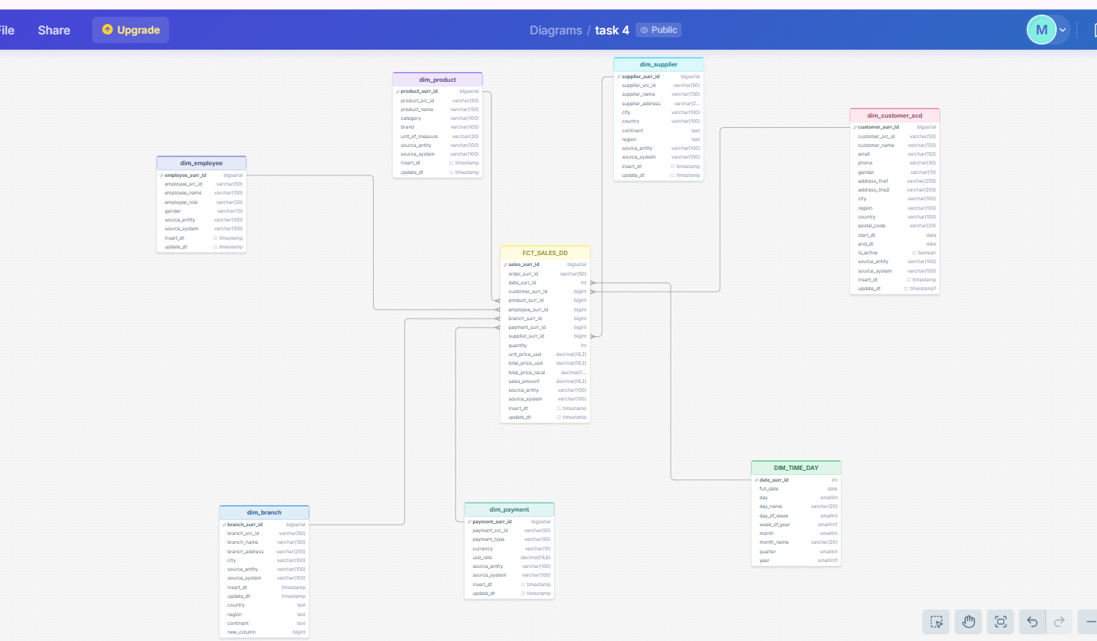
lint to the diogram

